**Name: Swapnadeep Mishra**

**CLOUD LAB**

**Assignment – 5**

**Group -A3**

**Roll No- 002211001115**

At first we open the openstack dashboard and login into it.

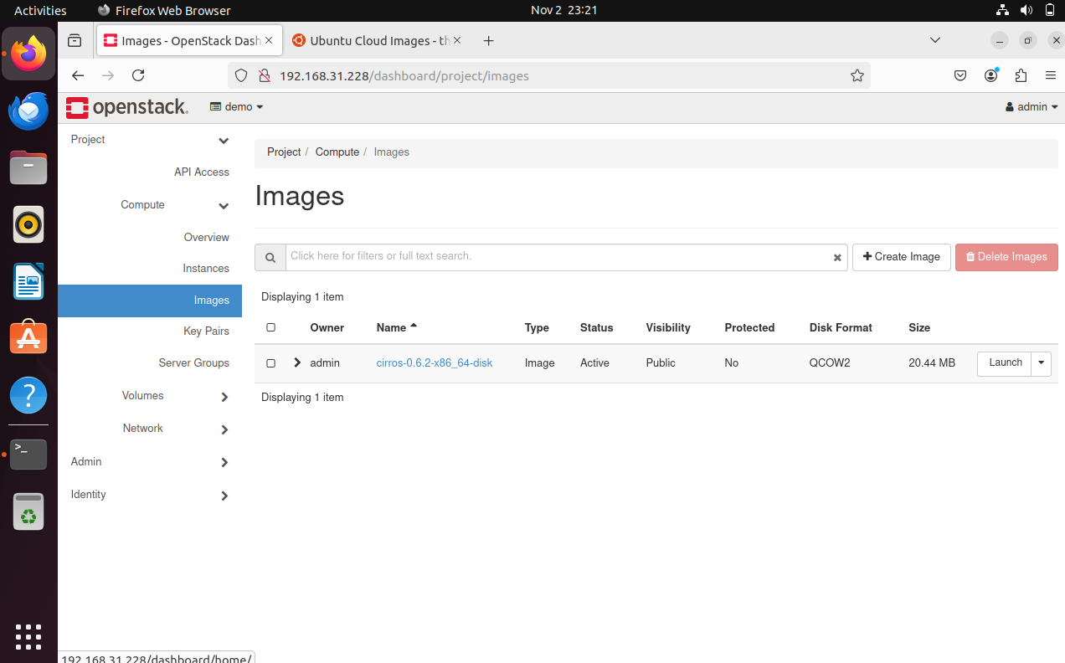

Then we open the website cloud-images.ubuntu.com and download a image from /noble directory and downloaded cloudimg.arm64.img.

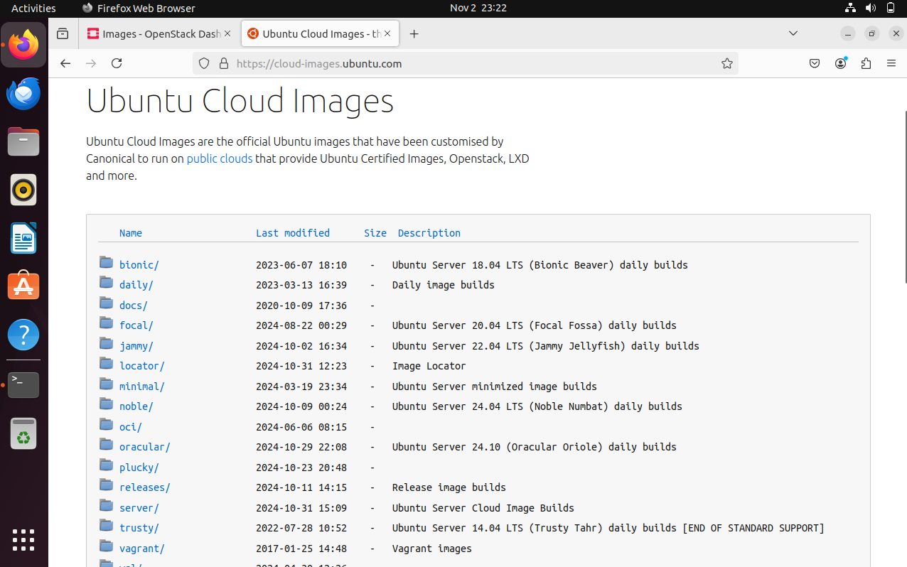

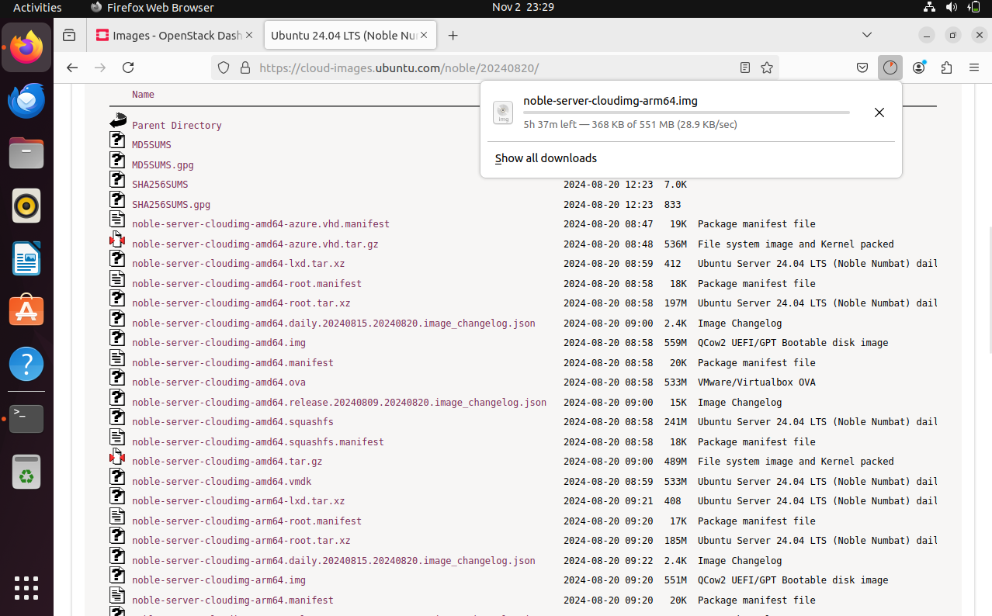

Then we go to create an image and put the downloaded image into it.

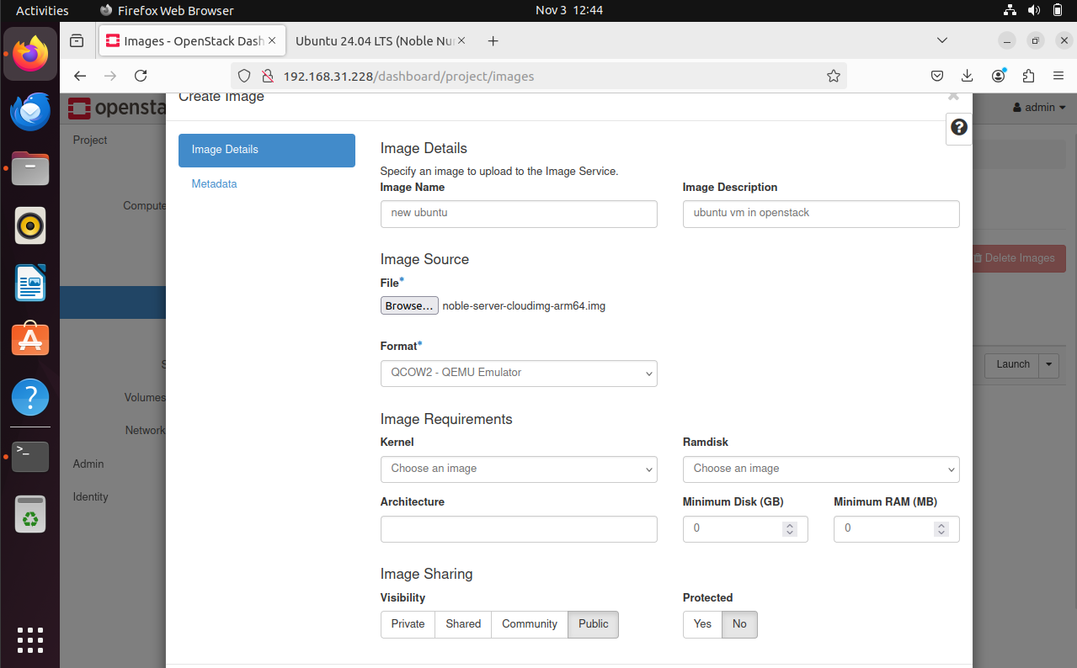

After that , we created a flavor to the image by giving a cpu size of 4 and Root Disk size as 10 Gb.

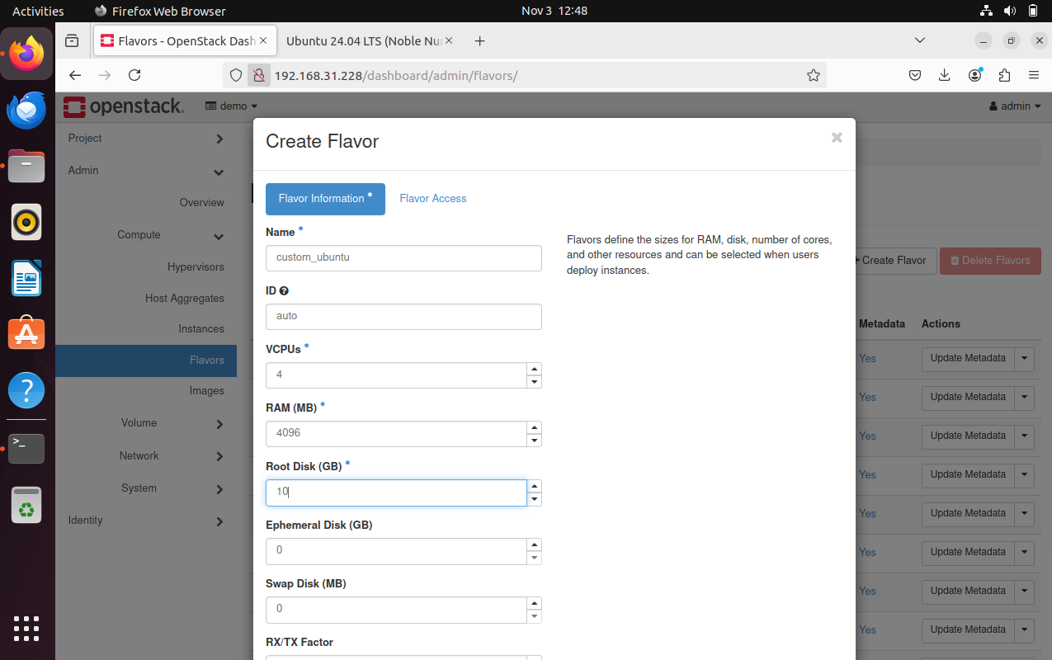

Then we continue to create networks.

**Public Network:**

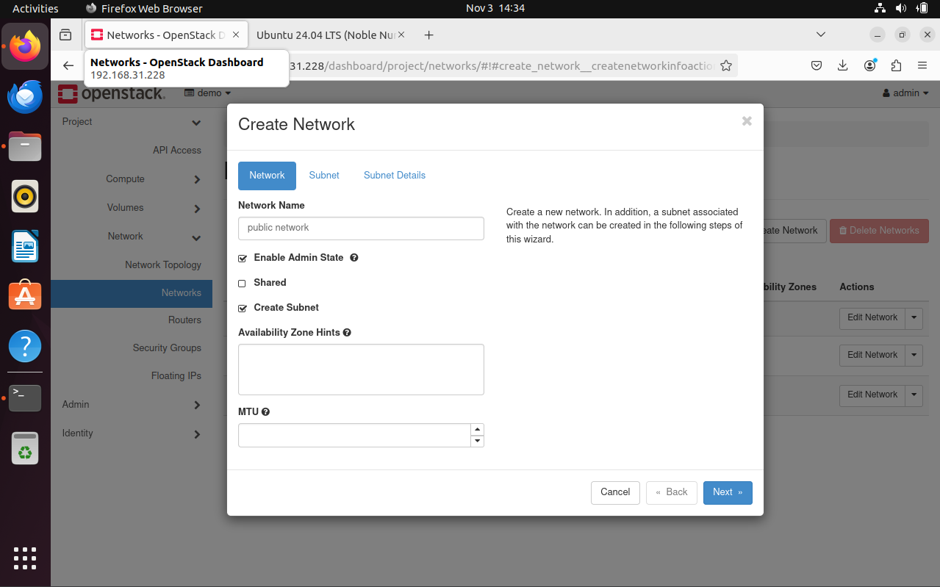

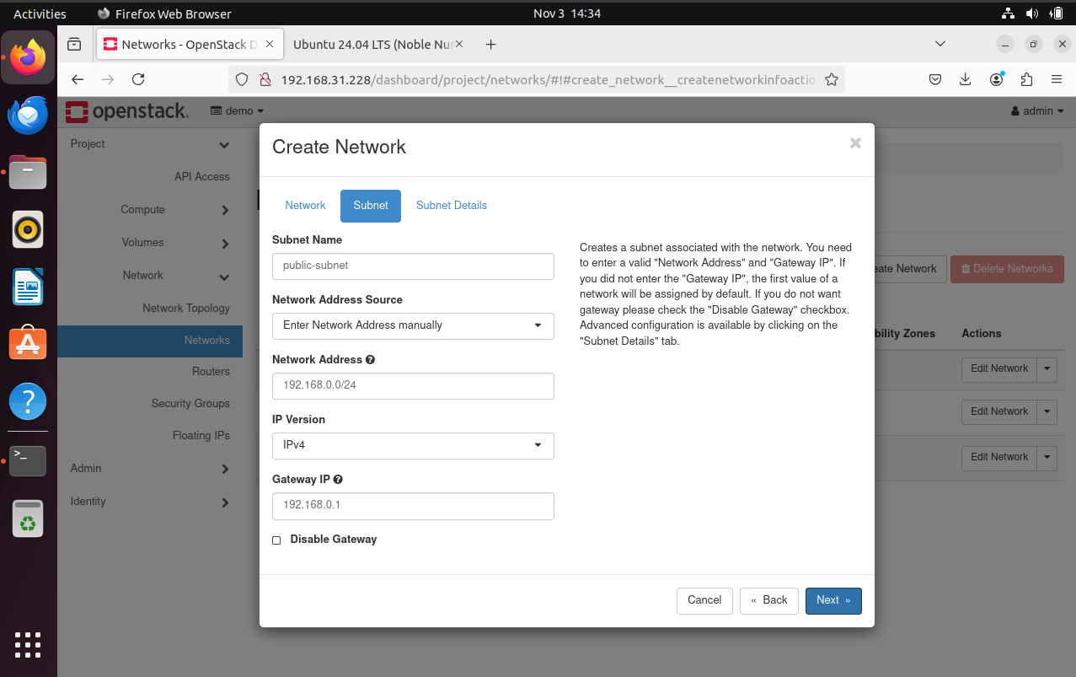

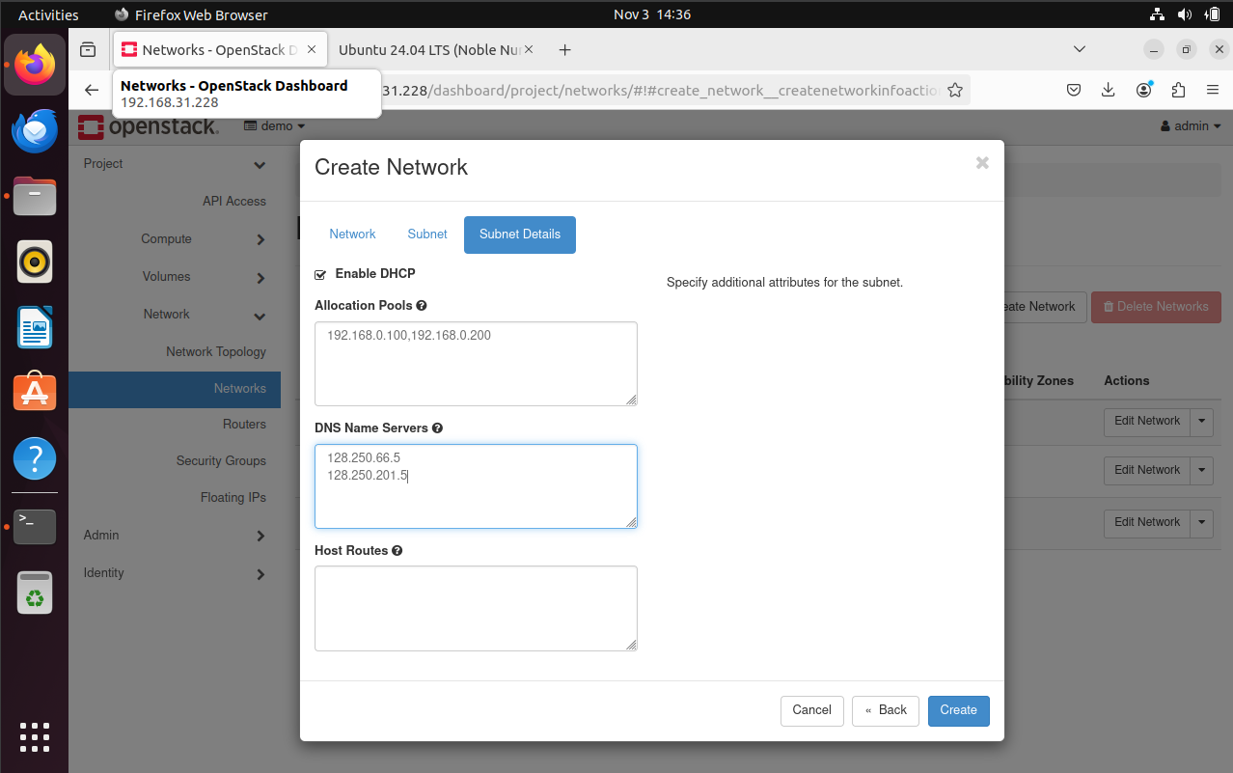

**Private network:**

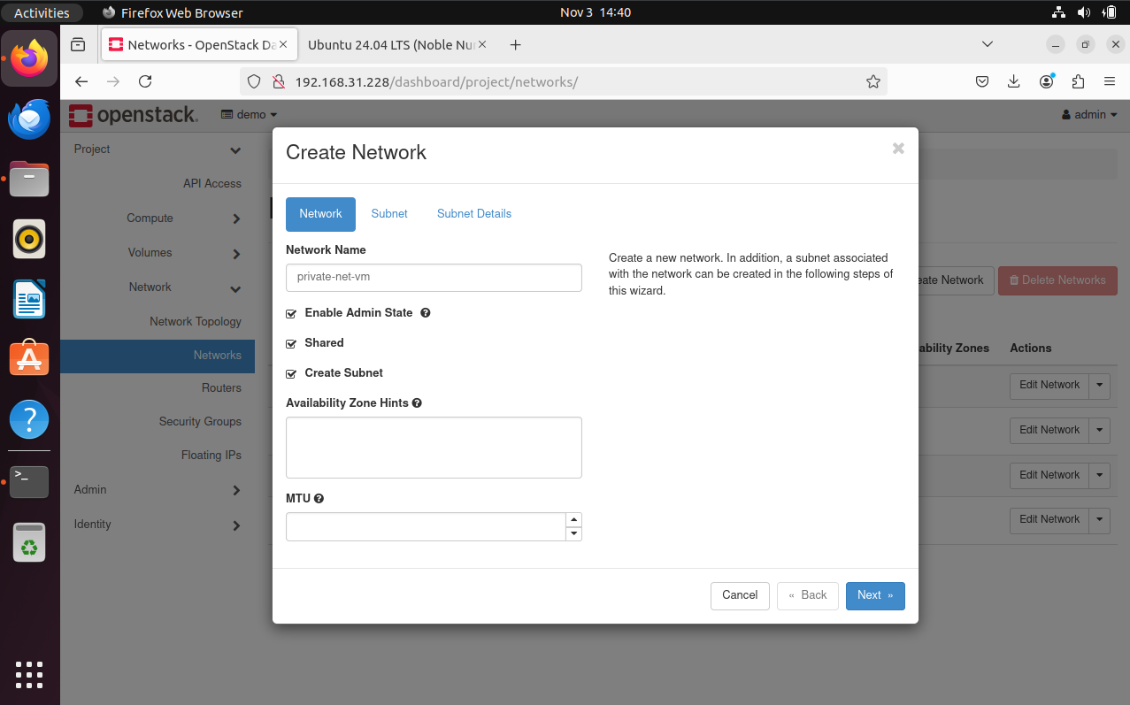

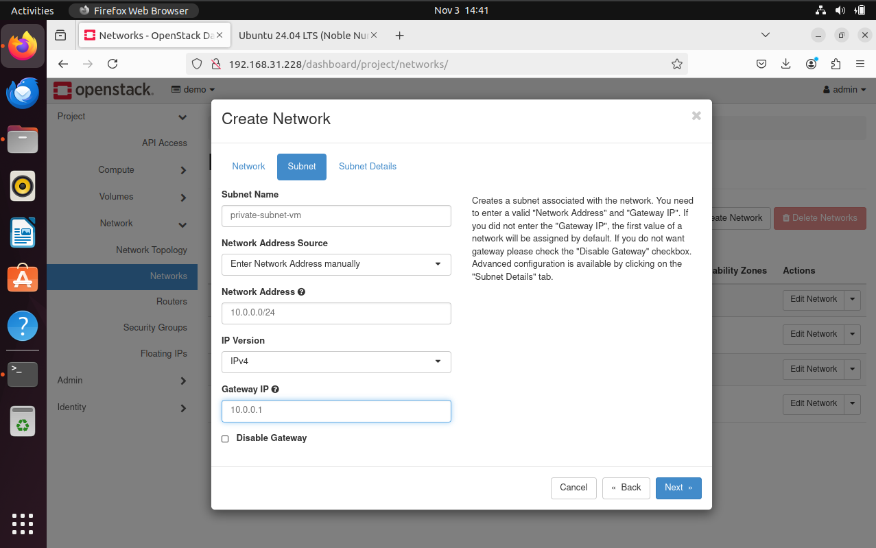

After creating networks er created a router.

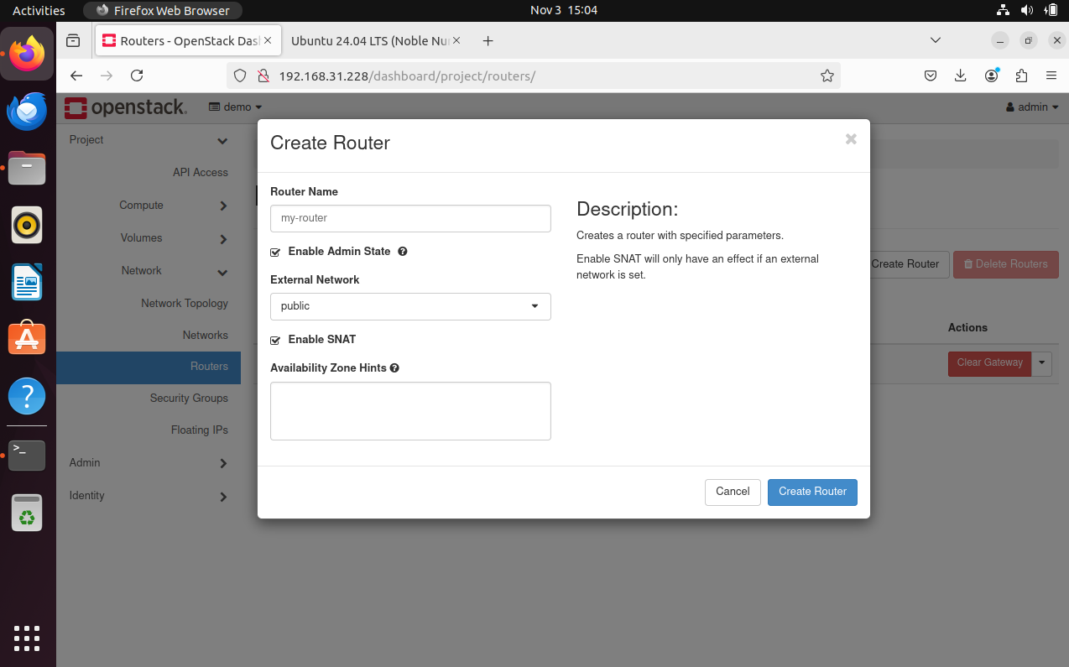

After router got created we add an interface to the router.

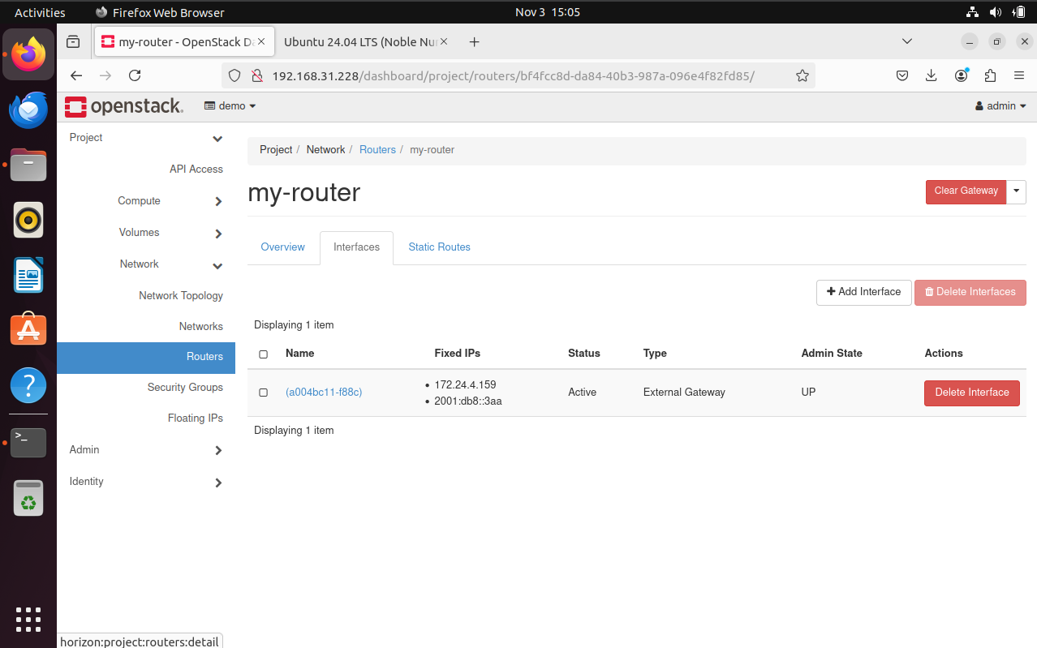

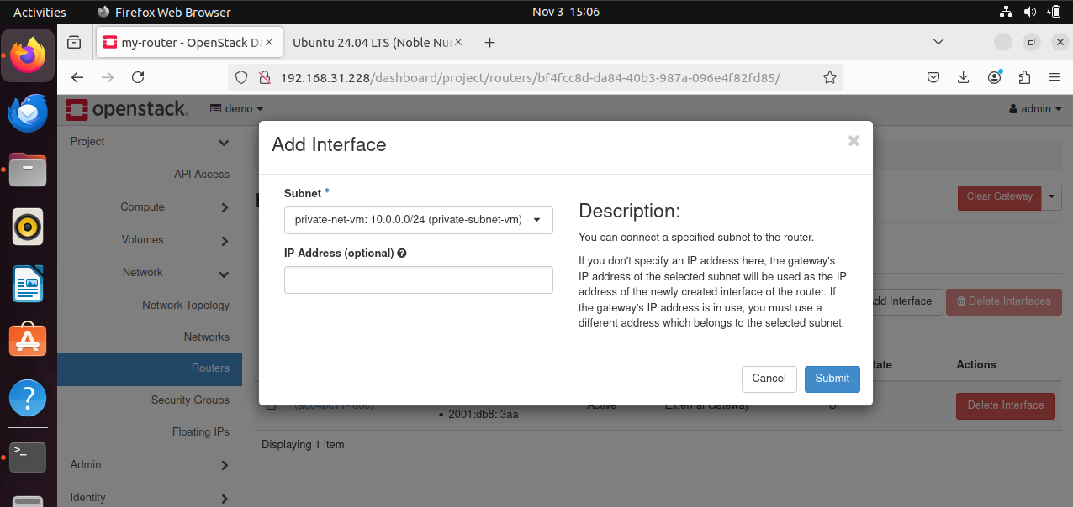

Then we started creating instances. Here are the settings below to create an instance.

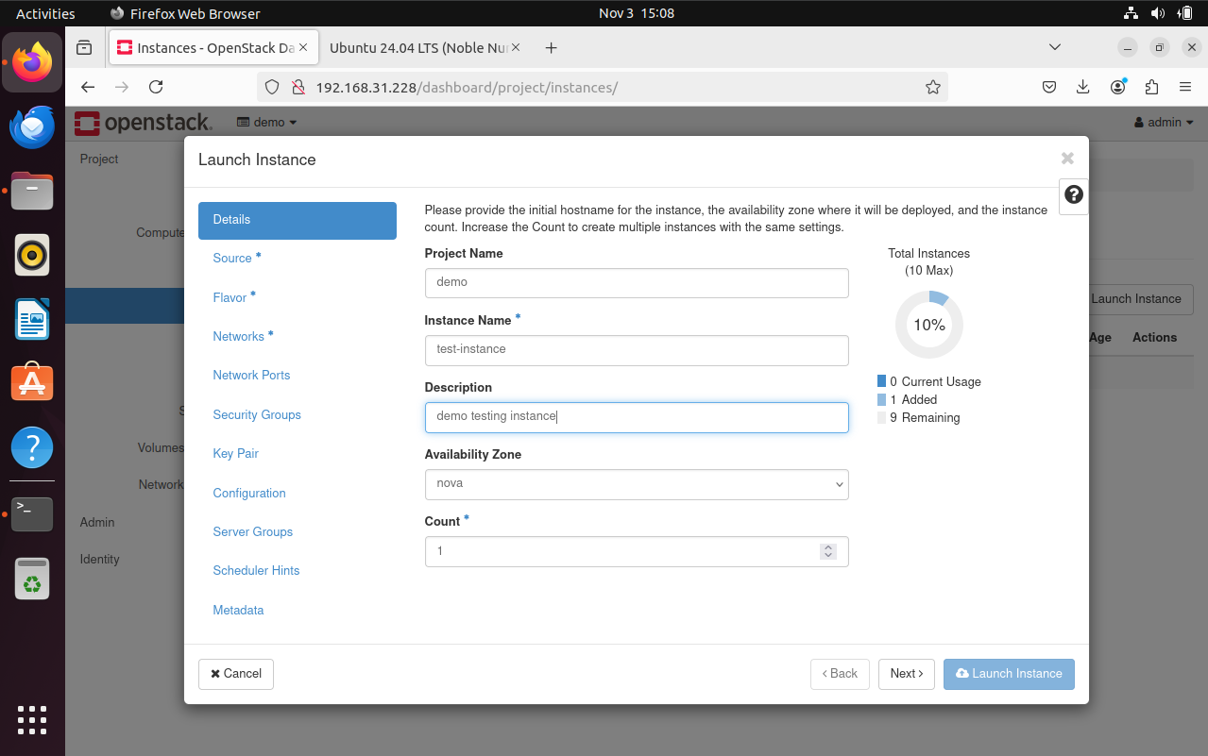

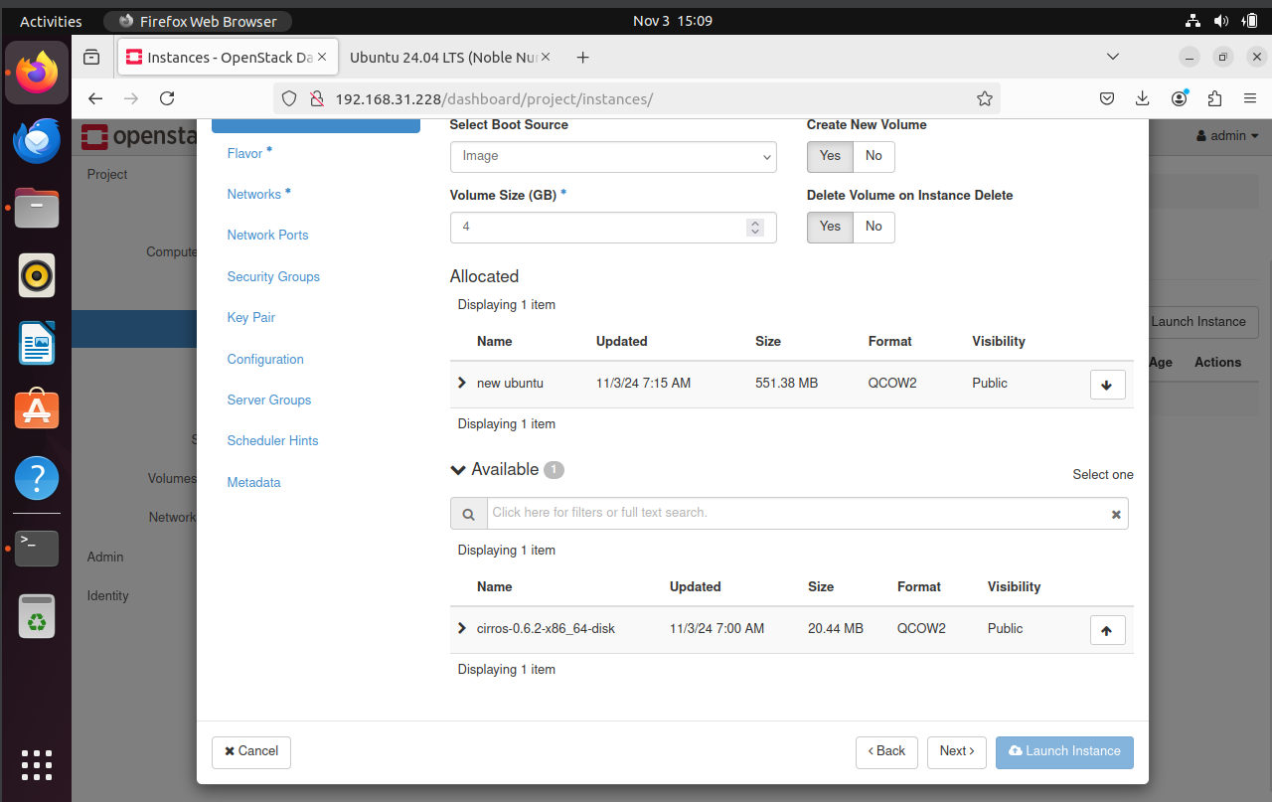

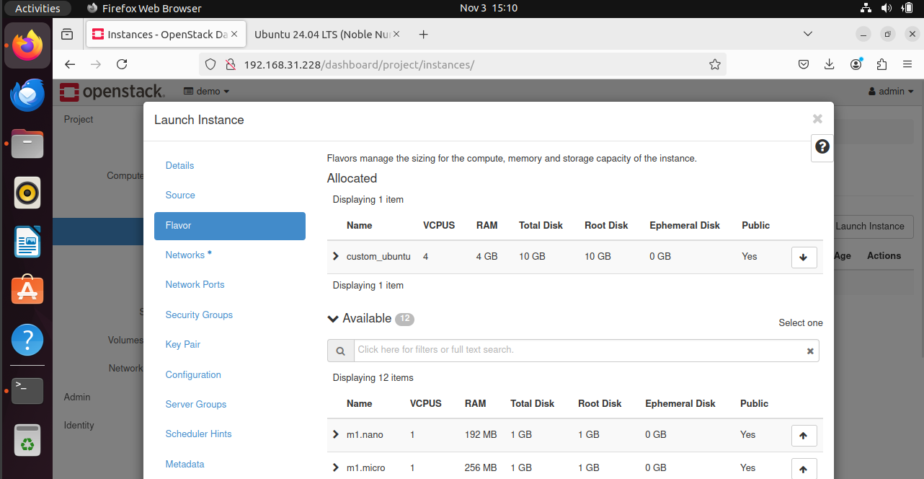

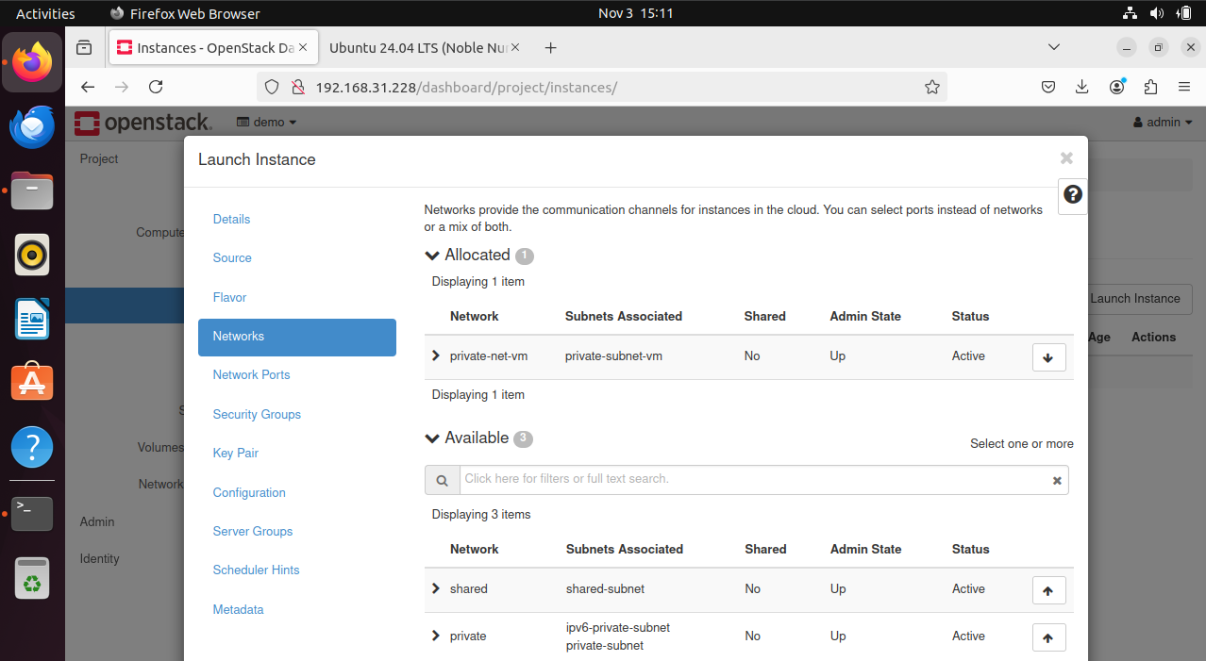

When creating key pairs we have to go to terminal(ssh) before importing the key pair. In the terminal a command must be entered. The command is ‘ ssh-keygen -t rsa -f cloud.key’. So to see the file what is created we can type ‘cat cloud.key.pub’ and copy the text from the terminal and paste it to the key pair settings.

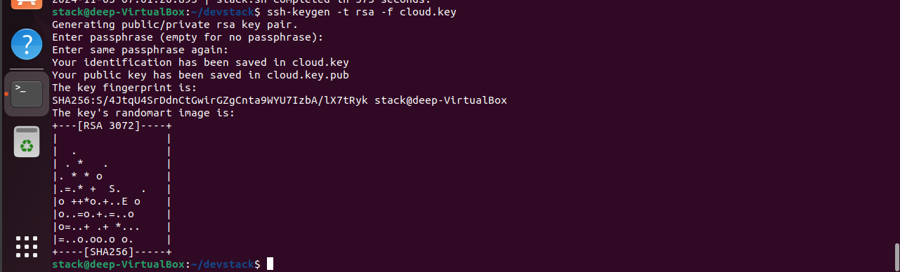

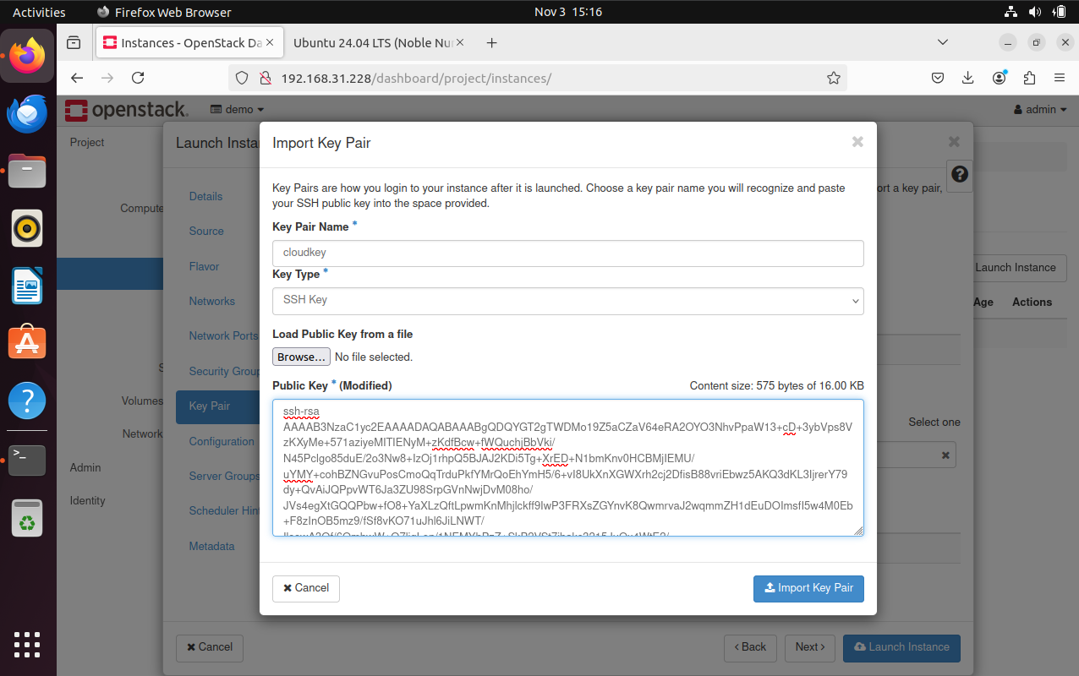

After that we can see that the instance is successfully created.

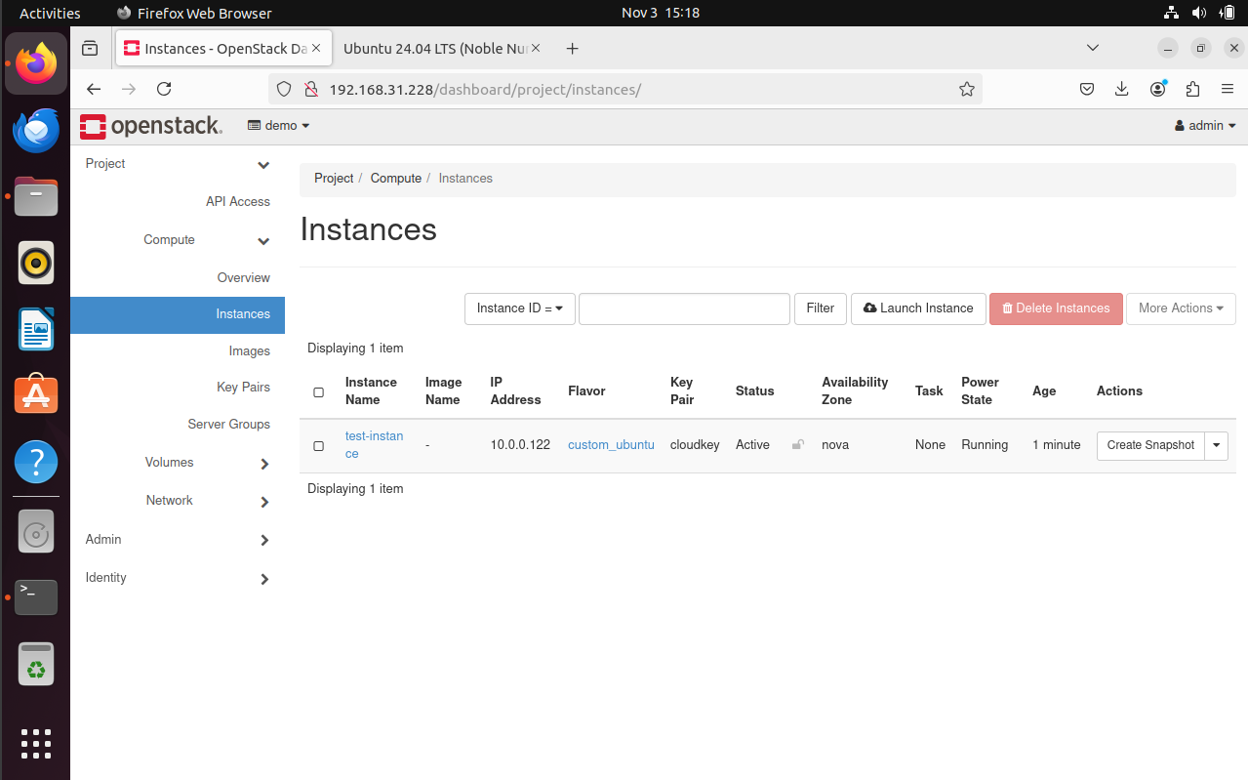

After creating an instance we clicked on associate floating ip’s and then clicked on associate.

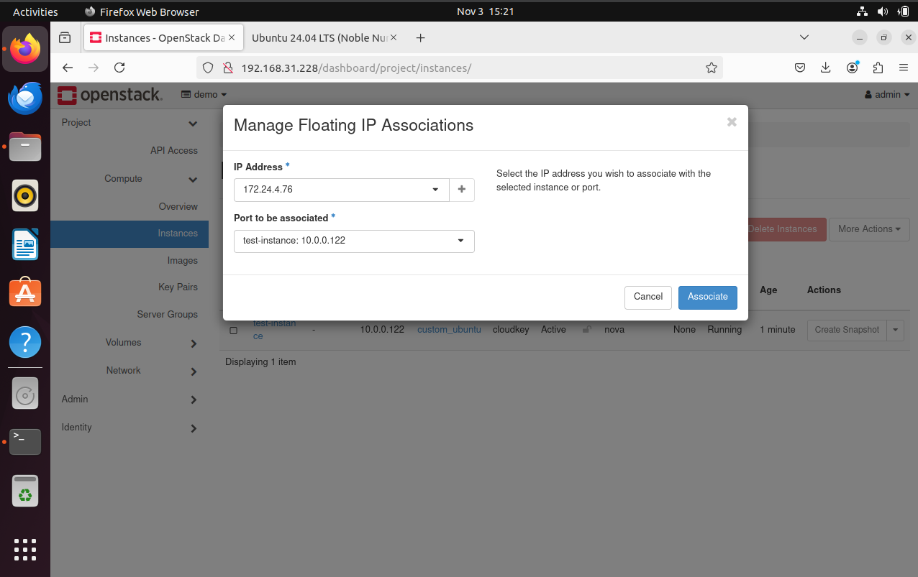

Then after typing the command below we should type the floating ip that is created before. And we must log in to the page by typing the ip address and then some filename like index.html.



**Error:**

The page didn’t log in. Showing that connecrion timed out. So we can’t process our task after that.